Project Design Phase-II Technology Stack (Architecture & Stack)
Date | 18 February 2026
Team ID | LTVIP2026TMIDS24254
Project Name | Visualization Tool for Electric Vehicle Charge and Range Analysis
Maximum Marks | 4 Marks

Technical Architecture:
The Deliverable shall include the architectural diagram as below and the information as per the table1 & table 2
Example: Order processing during pandemics for offline mode
Reference: https://developer.ibm.com/patterns/ai-powered-backend-system-for-order-processing-during- pandemics/

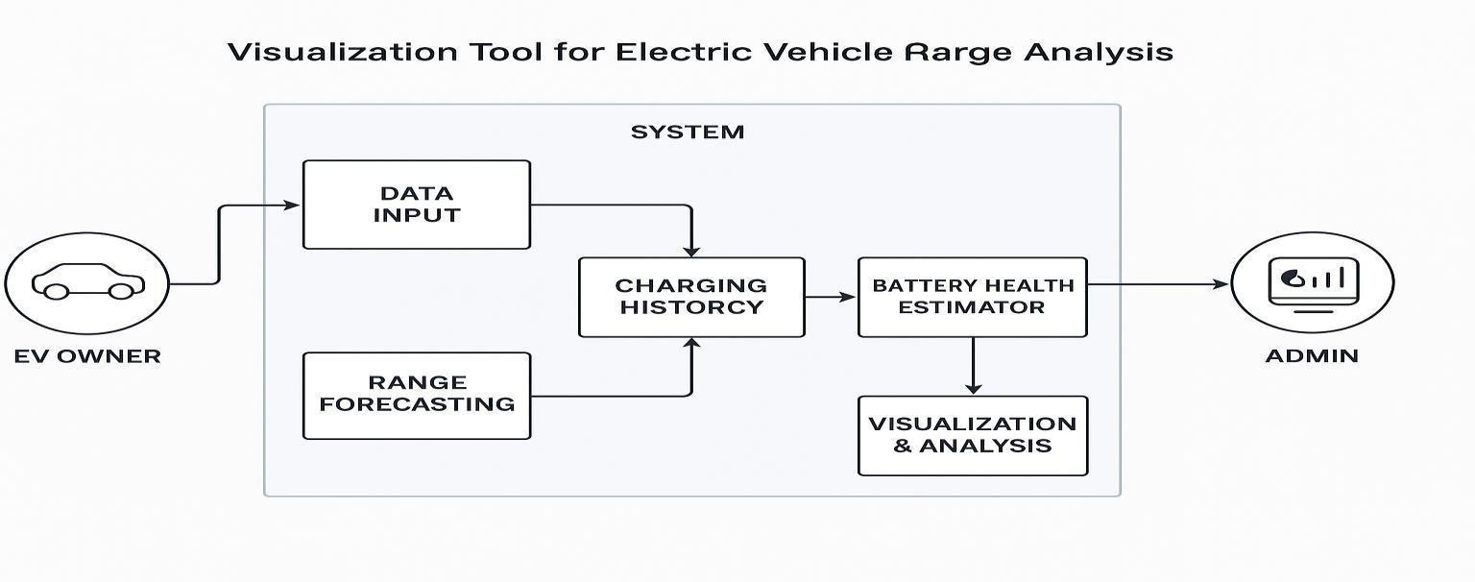

Table-1 : Components & Technologies:

S.No | Characteristics | Description | Technology
1. | Performance | Rapid data response for range calculations, map updates, and analytics | Redis Cache, CDN, Async Processing
2. | Maintainability | Easy to update components like maps, APIs, or authentication without affecting the entire system | Modular Design, Git-based CI/CD.
S.No | Component | Description | Technology
1. | User Interface | Provides interactive views for EV Owners, Admins, and Analysts | HTML, CSS, JavaScript, React or Vue.js
2. | Authentication Module | Handles secure login, signup, and role-based access | Firebase Auth, OAuth 2.0, JWT
3. | Vehicle Input System | Allows users to enter battery %, vehicle model, and trip preferences | JavaScript Form Logic, Python Flask AP
4. | Range Estimation Engine | Calculates real-time range based on input and terrain data | Python, Pandas, NumPy
5. | Charging Station Mapper | Displays nearby stations and highlights reachable zones. | Leaflet.js, Google Maps API
6. | Charging History Module | Visualizes past charging sessions with analytics | Chart.js, D3.js, MongoDB.
7. | Recommendation System | Suggests ideal routes and charging stops | Machine Learning Model, Scikit-learn
8. | Admin Dashboard | Admin access to station management and user analytics | React Admin, Node.js, MongoDB
9. | Database | Stores user data, station info, vehicle profiles | MongoDB, Firebase Firestore
10. | Hosting & Deployment | Runs backend and frontend on scalable infrastructure | Vercel, Netlify, AWS EC2 or Azure App Service.
11. | API Integration Layer | Connects external services like Maps and EV data APIs | REST APIs, GraphQL, Axios.

Table-2: Application Characteristics:
S.No | Characteristics | Description | Technology
3. | Scalable Architecture | Ensures the system handles increasing users, stations, and data; follows modular principles for flexibility | Microservices, Docker, Kubernetes
4. | Availability | Stable performance across user scenarios with accurate real-time outputs | Load Balancer (NGINX), Multi-region Hosting (Azure/AWS)
5. | Reliability | Design consideration for the performance of the application (number of requests per sec, use of Cache, use of CDN’s) etc. | Automated Testing, Monitoring (Prometheus, Grafana)

